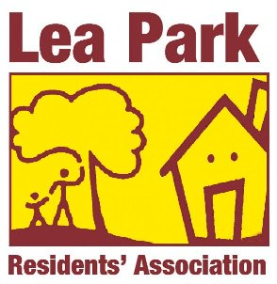 LEA PARK RESIDENTS’ ASSOCIATION

MEMBERSHIP FORM

Title Mr / Mrs / Miss / Ms

Forename ………………………….

Surname …………………………

Address ………………………………………………………

………………………………………………………

Preferred Contact Number …………………………………

Email Address ……………………………………………………

Payment Method Standing Order / Cash / Cheque

(Please circle chosen method)

Please email form to [leapark@hotmail.co.uk](mailto:leapark@hotmail.co.uk) , or drop into the LPRA Box at the Town Hall or post it to LPRA, c/o Thame Town Hall, High Street, Thame OX9 3DP